Elton, Gruber, Brown, and Goetzmann
Modern Portfolio Theory and Investment Analysis, 9th Edition
Solutions to Text Problems: Chapter 23

Chapter 23: Problem 1

Although selling calls today would generate a positive cash flow for the client now, the client would lose the potential profit he would make if the stock were to appreciate in value, because the stock would be called away from the client. Thus, there is a potential opportunity cost of engaging in that strategy.

Chapter 23: Problem 2

The profit diagram of buying the two puts appears as follows:

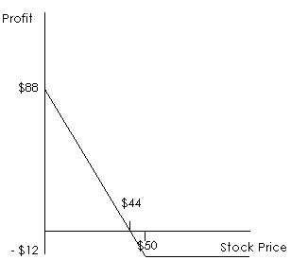

The profit diagram of buying the call appears as follows:
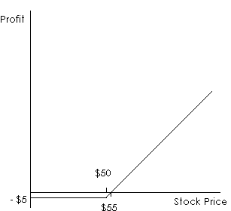

Combining the two profit diagrams we have:
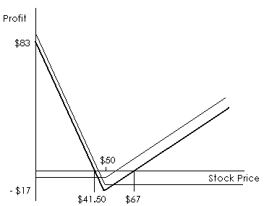

The thicker line in the above diagram represents the profit from the combination. If the options finish at the money, where the stock price at their expiration equals their strike prices of $50, the profit would be − $17 (a $17 loss). For the combination to have a positive profit, the stock must either be below $41.50 or above $67 on the day the options expire.

Algebraically, letting the stock price on the expiration date = P, the profit is:

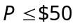:

Profit = − $17 + 2 × ($50 − P) = $83 − 2P (since only the two put options would be exercised)

$50 < P:

Profit = − $17 + P − $50 = P − $67 (since only the call option would be exercised)

Chapter 23: Problem 3

The profit diagram of writing the two $45 calls appears as follows:

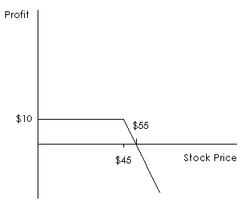

The profit diagram of buying the $40 call appears as follows:

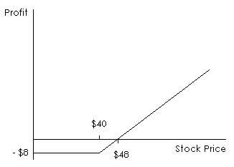

Combining the two profit diagrams we have:

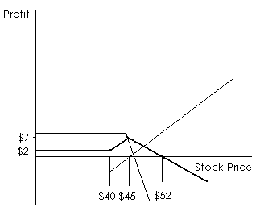

The thicker line in the above diagram represents the profit from the combination. If the $40 call option finishes out of or at the money, where the stock price at its expiration is below or equal to that option’s strike price of $40, the profit would be $2, because none of the options would be exercised and therefore the profit is simply the net profit from buying the $40 call option (− $8) and selling the two $45 call options ($10). If the two $45 call options finish at the money, where the stock price on their expiration equals their strike price of $45, the profit would be $7, equal to the net profit of $2 from buying and writing the options plus the $5 gain from exercising the $40 call option. $7 is the maximum profit because, at stock prices higher than $45, although exercising the $40 call option continues to contribute a gain, the two $45 call options that were sold will be exercised against the seller and therefore contribute twice the loss, so the profit declines, reaching zero at a stock price of $52. (At a stock price of $52, the profit from the $40 call will be $12 − $8 = $4 and the profit from the two $45 calls will be −$14 + $10 = − $4, giving a total profit of 0.) If the stock price is greater than $52 on the expiration date, the profit will be negative (a loss).

Algebraically, letting the stock price on the expiration date = P, the profit is:

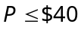:

Profit = $2 (since no options would be exercised)

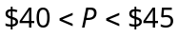:

Profit = $2 + P − $40 (since only the $40 call option would be exercised)

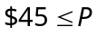:

Profit = $2 + P − $40 − 2 × (P − $45) = $52 − P (since all options would be exercised)

Chapter 23: Problem 4

From the text, we know that a is the lowest number of upward moves in the stock price at which the call takes on a positive value at expiration (finishes in the money), u is the size of each up movement, d is the size of each down movement and n is the number of periods remaining to the option’s expiration. Given that the option’s exercise price (E) is $60 and the current stock price (S₀) is $50, we need to solve for the minimum integer a such that:

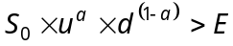

So we have:

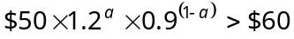

and the solution is a = 5.

To value the call option, we use the binomial formula:

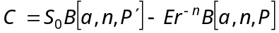

where

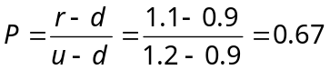

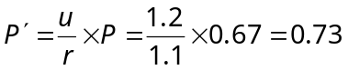

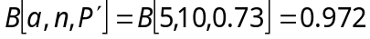

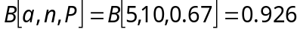

So we have:

Chapter 23: Problem 5

The Black-Scholes option-pricing formula for valuing a call option is:

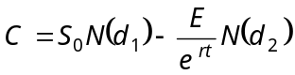

We are given:

S₀ = $95; E = $105; t = 2/3 years (8 months); σ = 0.60; r = 0.08 (8%)

Solving for d₁ and d₂ we have:

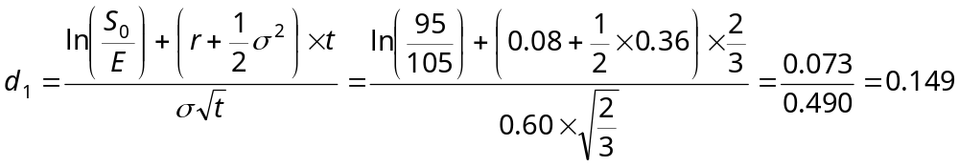

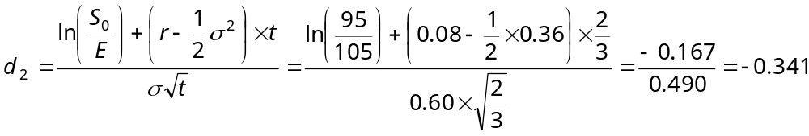

From the normal distribution we have:

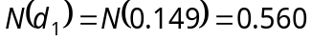

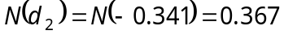

So the value of the call option is:

